Mark Klobukov

CS 383: Machine Learning

Professor Burlick

2/1/2018

**Clustering Part I**

1) Before clustering:

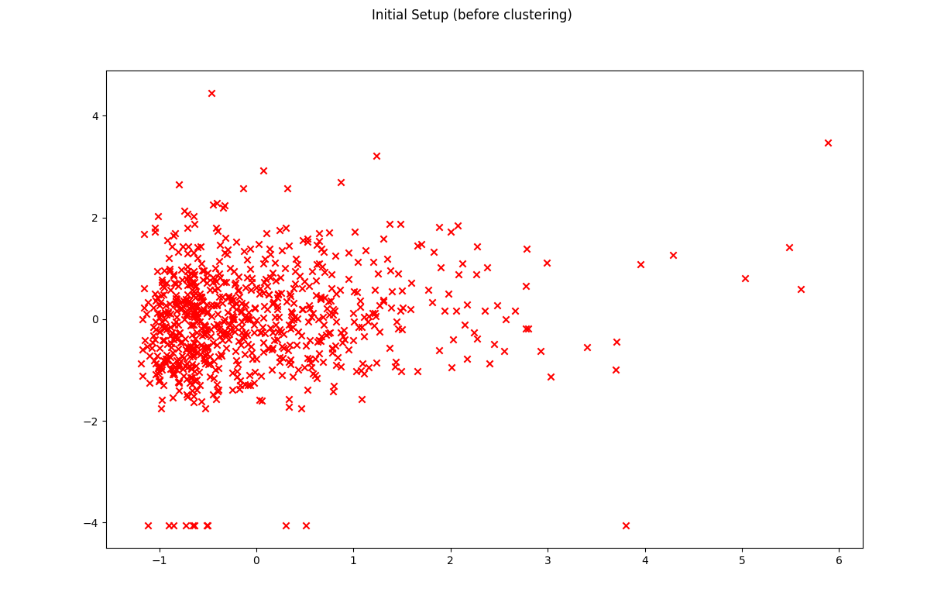

2) Clustering after one iteration of the k-means algorithm:

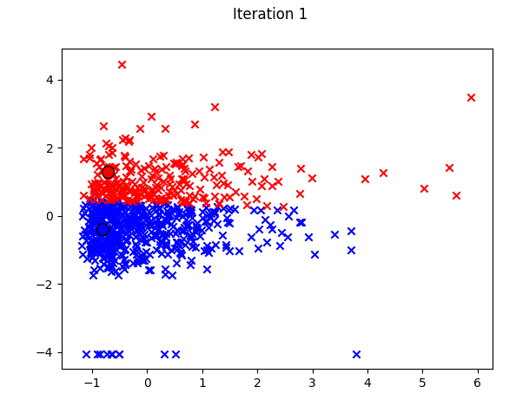

3) Clustering after algorithm termination:

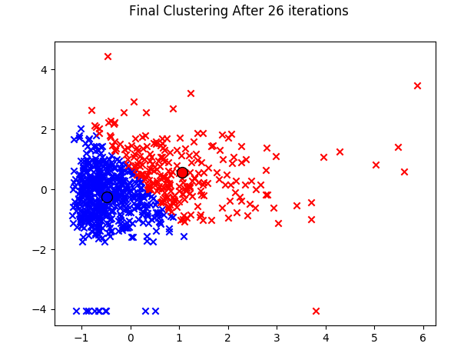

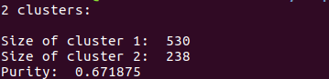

**Purity Calculations:**

Purity was found using the following formula:

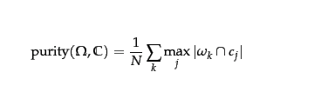

where $ω_{k}$ is cluster k and $c_{j}$ is class j. In this case, there are two clusters and two classes (the classes correspond to the label -1 or 1 in the first column of the data).

Result of purity calculation is printed to the terminal after running the `kmeans.py` code. Calculated purity value if 0.671875:

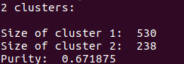

**Clustering Part II**

Example 1: All features used in the algorithm

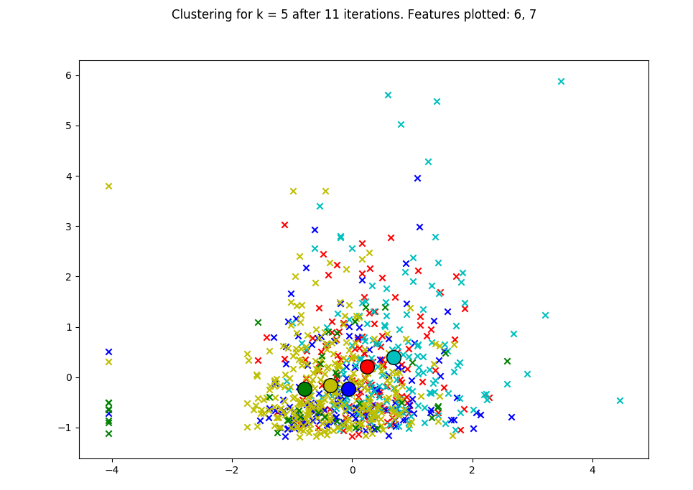

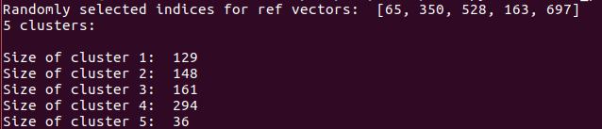

Example 2: All features used in the algorithm 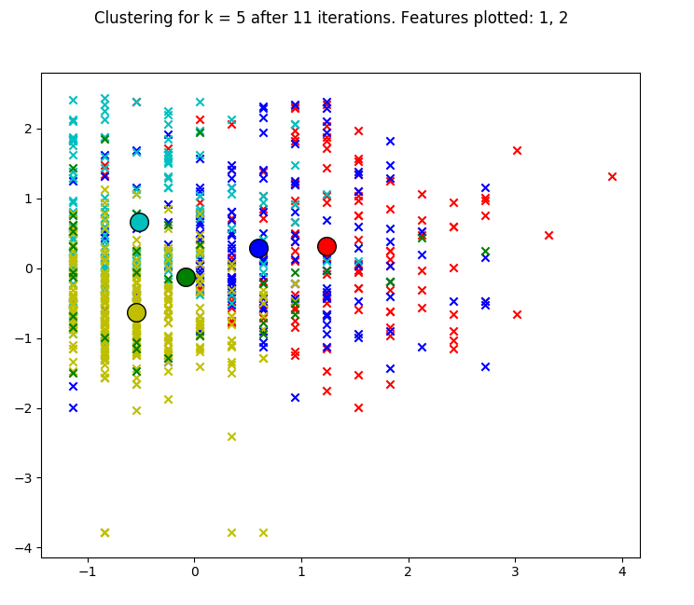

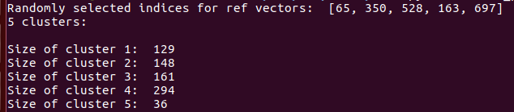

Example 3: All features used in the algorithm

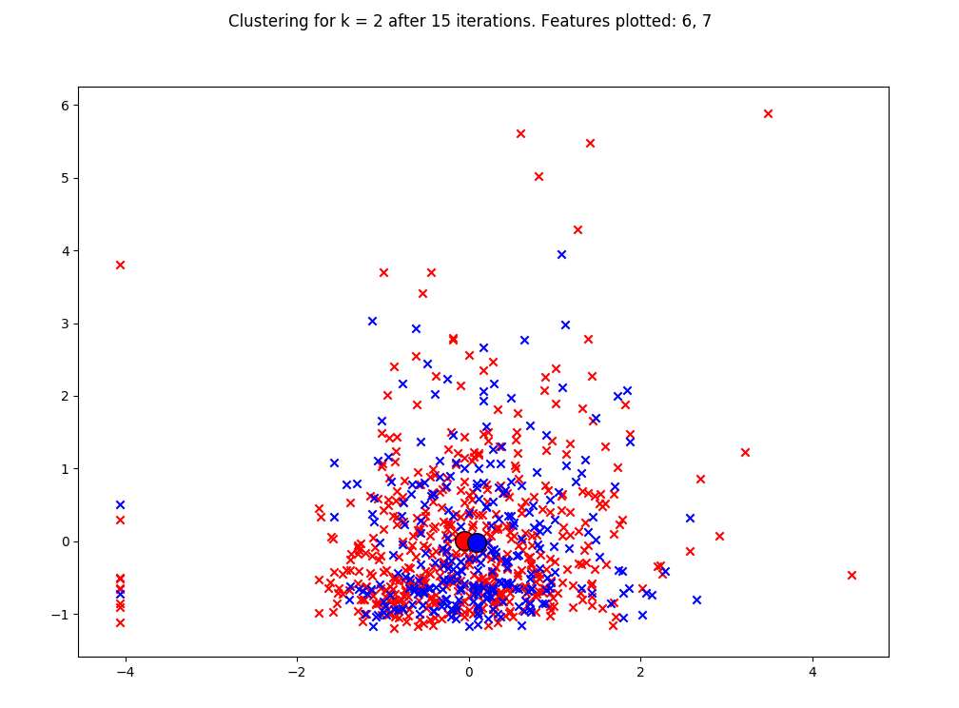

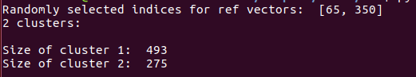

Example 4: All features used in the algorithm

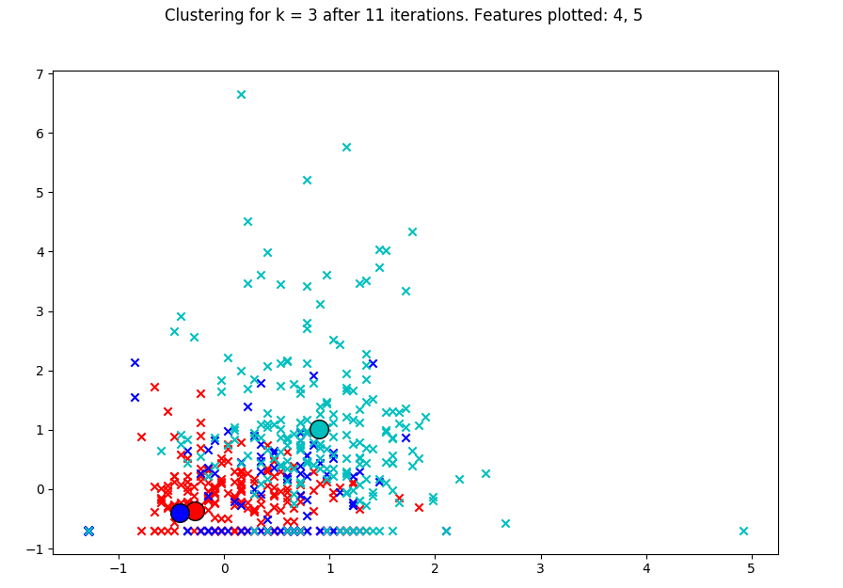

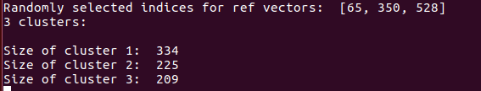

Example 5: All features used in the algorithm

